**Lab Assignment No. 3**

Write a Python Program using Perceptron Neural Network to recognise even and odd numbers. Given numbers are in ASCII form 0 to 9

**Code:**

import matplotlib.pyplot as plt  
import pandas as pd  
import numpy as np  
import seaborn as sns

data = {"Numberes" : [1,3,5,4,2,9,7,6,8], "Tag" : [0,0,0, 1,1,0,0,1,1]}  
df = pd.DataFrame(data)

df

Numberes Tag  
0 1 0  
1 3 0  
2 5 0  
3 4 1  
4 2 1  
5 9 0  
6 7 0  
7 6 1  
8 8 1

x = df["Numberes"]  
y = df["Tag"]

sns.scatterplot(x=df["Numberes"],y=y, hue=y)  
plt.plot([0.5 for _ in df["Tag"] ])

[<matplotlib.lines.Line2D at 0x7f3457dc1ac0>]

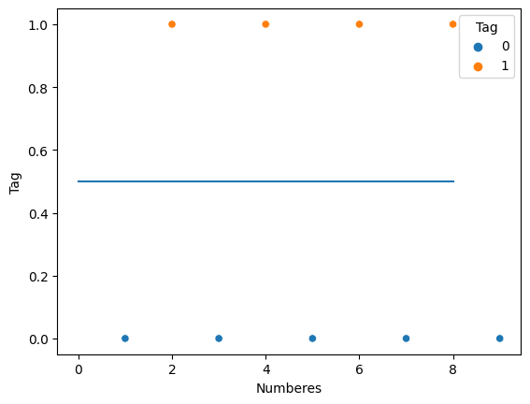

2 * np.random.random((10, 1)) - 1

array([[-0.35812149],  
 [ 0.47412758],  
 [ 0.62511668],  
 [-0.89430268],  
 [ 0.32154228],  
 [ 0.08212657],  
 [ 0.4911432 ],  
 [ 0.7819753 ],  
 [ 0.92660091],  
 [ 0.62252329]])

array([[ 0.2082653 ],  
 [-0.74252417],  
 [-0.77242322],  
 [-0.86954873],  
 [ 0.33953798],  
 [ 0.74940269],  
 [-0.29060187],  
 [-0.72214394],  
 [-0.49388729],  
 [-0.09347683]])

int(bin(2)[2:])

10

a = [np.random.choice([0,1]) for _ in range(4)]  
a

[0, 1, 0, 1]

1 if 8>0 else 0

1

np.ones(4)

array([1., 1., 1., 1.])

a = 2 + np.dot([1,2, 4], [2, 2,2])  
a

16

#Class for binary input

class Perceptron():  
 def __init__(self, epochs, lr, input_size):  
 self.weight = np.ones(input_size)  
 self.epochs = epochs  
 self.lr = lr  
 self.bias = 0.0  
  
 def predict(self, x_test):  
 a = self.bias  
 for i in range(len(x_test)):  
 a += self.weight[i] * x_test[i]  
 return 1 if a>=0 else 0  
  
 def train(self, train_data):  
 for i in range(self.epochs):  
 for x_train, y_train in train_data:  
 predicted = self.predict(x_train)  
 error = y_train - predicted  
 self.bias += self.lr * error  
 for j in range(len(self.weight)):  
 self.weight[j] += self.lr * error * x_train[j]

perceptron = Perceptron(1000, 0.001, 8)

perceptron.train([([0,0,0,0,0,0,0,1], 0), ([0,0,0,0,0,0,1,0], 1), ([0,0,0,0,0,0,1,1], 0), ([0,0,0,0,0,1,0,0], 1), ([0,0,0,0,0,1,0,1], 0), ([0,0,0,0,0,1,1,0], 1), ([0,0,0,0,0,1,1,1], 0), ([0,0,0,0,1,0,0,0], 1), ([0,0,0,0,1,0,0,1], 0), ([0,0,0,0,1,0,1,0], 1), ([0,0,0,0,1,0,1,1], 0)])

predictA = [ perceptron.predict(X_test) for X_test, i in [([0,0,0,0,0,0,0,1], 0), ([0,0,0,0,0,0,1,0], 1), ([0,0,0,0,0,0,1,1], 0), ([0,0,0,0,0,1,0,0], 1), ([0,0,0,0,0,1,0,1], 0), ([0,0,0,0,0,1,1,0], 1), ([0,0,0,0,0,1,1,1], 0), ([0,0,0,0,1,0,0,0], 1), ([0,0,0,0,1,0,0,1], 0), ([0,0,0,0,1,0,1,0], 1), ([0,0,0,0,1,0,1,1], 0)]]

perceptron.predict()

1

sns.scatterplot(x = [1, 2, 3, 4,5 ,6,7,8,9], y =[0, 1, 0, 1, 0, 1, 0, 1, 0])  
plt.plot(predictA)

[<matplotlib.lines.Line2D at 0x7f34580cc820>]

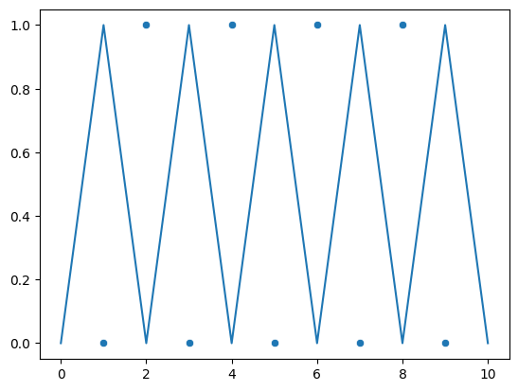

a = [int(i) for i in bin(21)[2:]]  
A = [0 for _ in range(8-len(a)) ] + a  
A

[0, 0, 0, 1, 0, 1, 0, 1]

#Class For ASCII Input

class Perceptron():  
 def __init__(self, epochs, lr, input_size):  
 self.weight = np.ones(input_size)  
 self.epochs = epochs  
 self.lr = lr  
 self.bias = 0.0  
   
 def predict(self, x_test):  
 a = self.bias  
 x_test = self.binary(x_test)  
 for i in range(len(x_test)):  
 a += self.weight[i] * x_test[i]  
 return 1 if a>=0 else 0  
  
 def binary(self, x):  
 a = [int(i) for i in bin(x)[2:]]  
 A = [0 for _ in range(8-len(a)) ] + a  
 return A  
  
 def train(self, train_data):  
 for i in range(self.epochs):  
 for x_train, y_train in train_data:  
 # print(x_train)  
 # print(x_train)  
 predicted = self.predict(x_train)  
 error = y_train - predicted  
 x_train = self.binary(x_train)  
 self.bias += self.lr * error  
 for j in range(len(self.weight)):  
 self.weight[j] += self.lr * error * x_train[j]

p = Perceptron(1000, 0.001, 8)

x_train = []  
for i in range(1, 100):  
 if i % 2 == 0:  
 x_train.append((i, 1))  
 else:  
 x_train.append((i, 0))

p.train(x_train)

p.weight

array([ 0.782, 0.781, 0.288, 0.288, 0.205, 0.183, 0.181, -1.749])

p.bias

-0.18000000000000005

predictions = [(i, p.predict(i)) for i in range(1, 13)]

predictions

**Output:**

Even odd numbers are:

[(1, 0),  
 (2, 1),  
 (3, 0),  
 (4, 1),  
 (5, 0),  
 (6, 1),  
 (7, 0),  
 (8, 1),  
 (9, 0),  
 (10, 1),  
 (11, 0),  
 (12, 1),  
 (13, 0)]